Integrating Databricks with GitHub

Step 1: Authenticate GitHub in Databricks
1) In Databricks, click your user icon (top right) and select Settings.
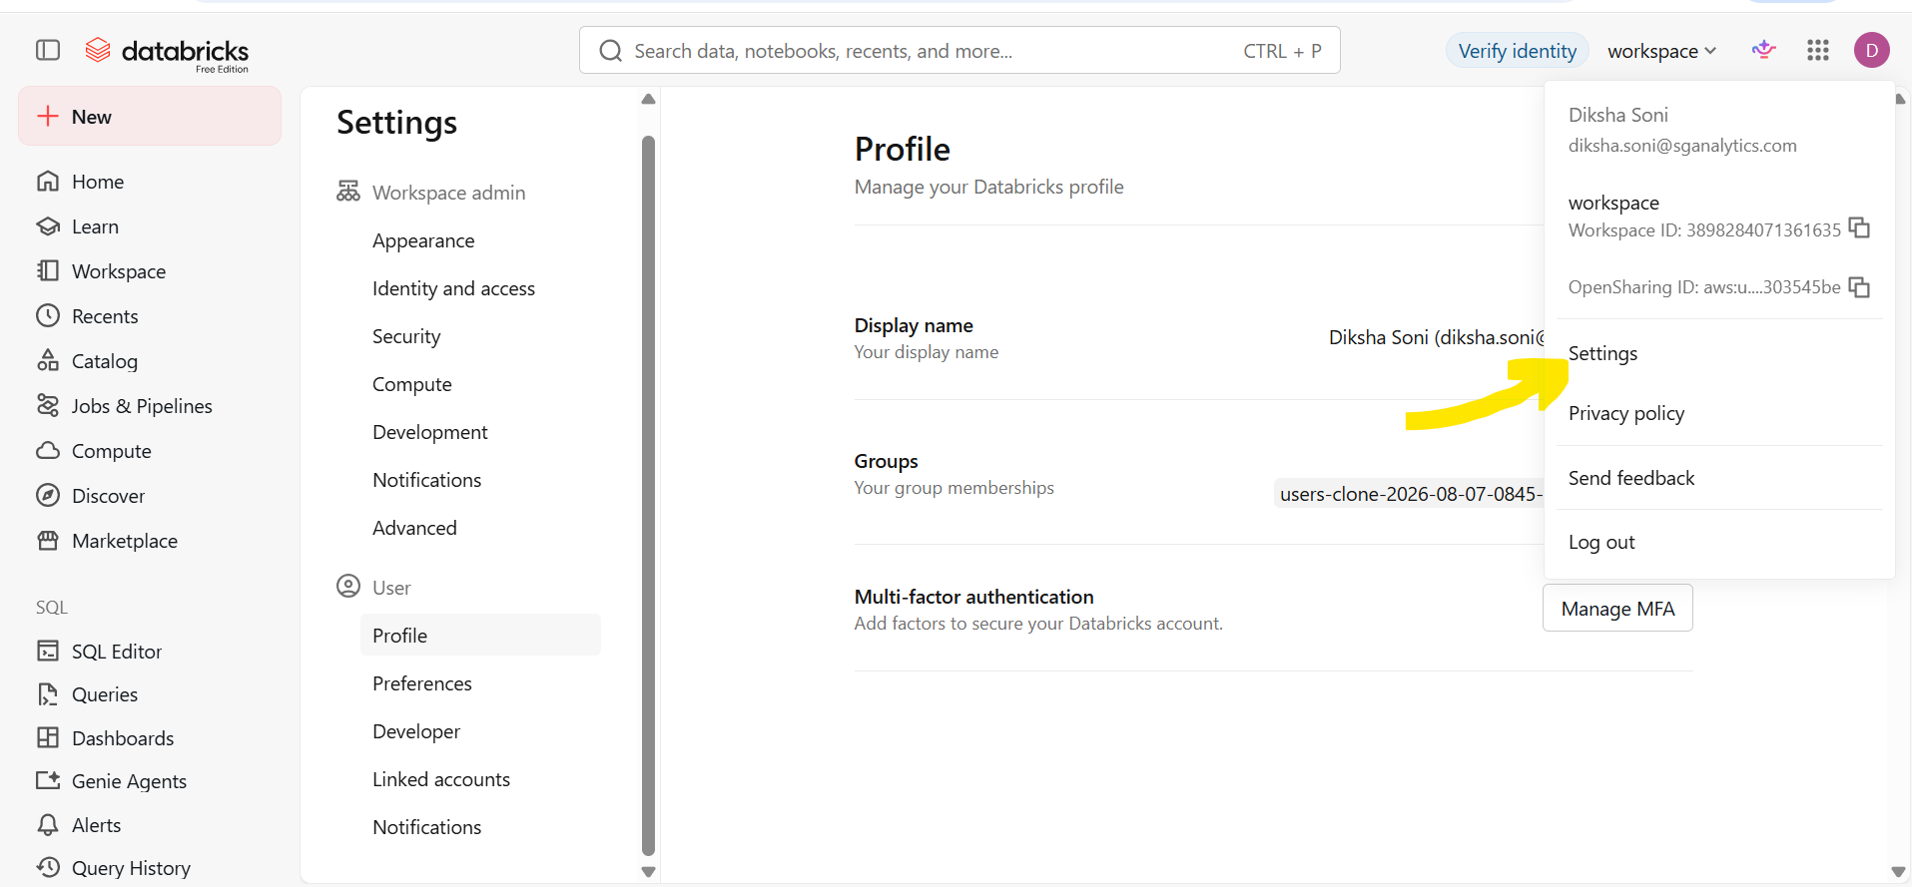
2) Select the Linked accounts tab.
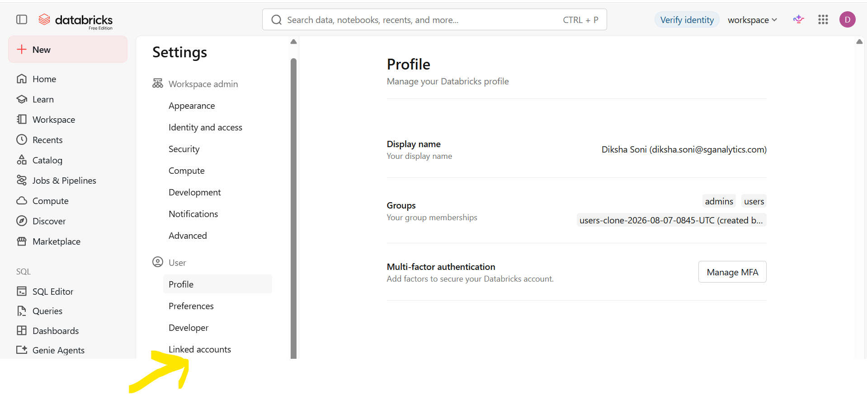
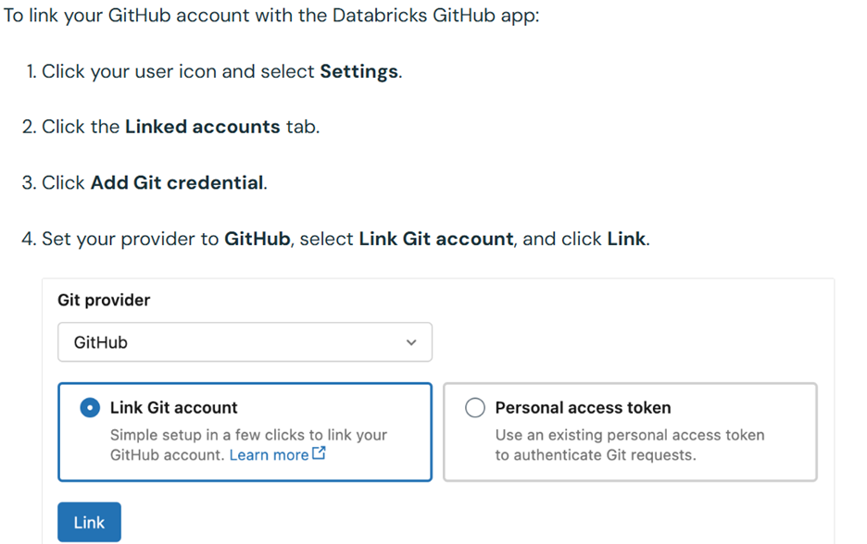
3) Authorize the Databricks GitHub App when prompted and choose which repositories Databricks can access.
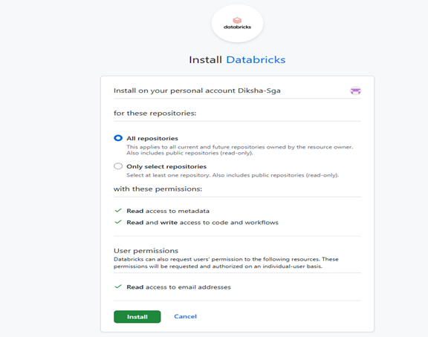
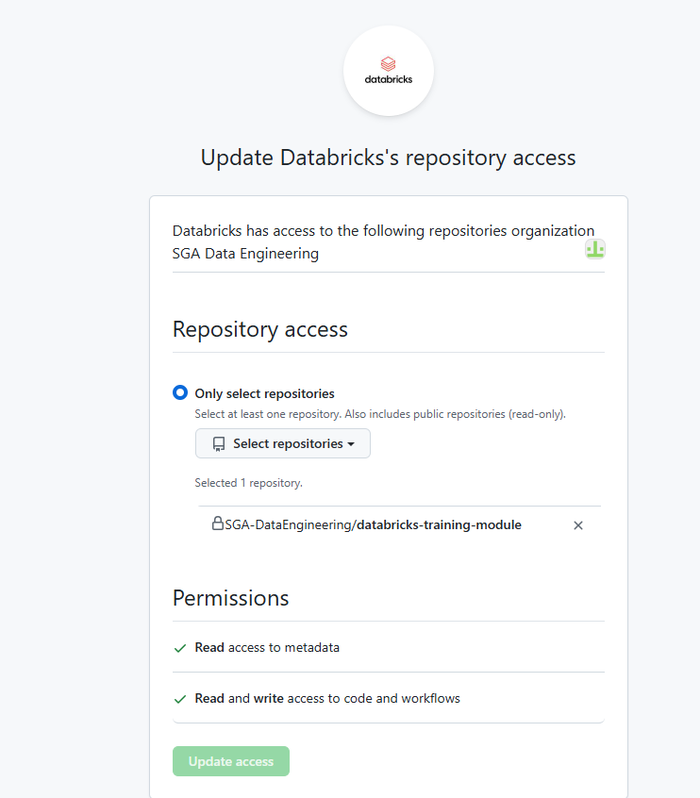
4) Connect your Git provider to Databricks:
https://docs.databricks.com/aws/en/repos/get-access-tokens-from-git-provider

Step 2: Clone Your Repository
- Go to the left sidebar in Databricks and click Workspace.
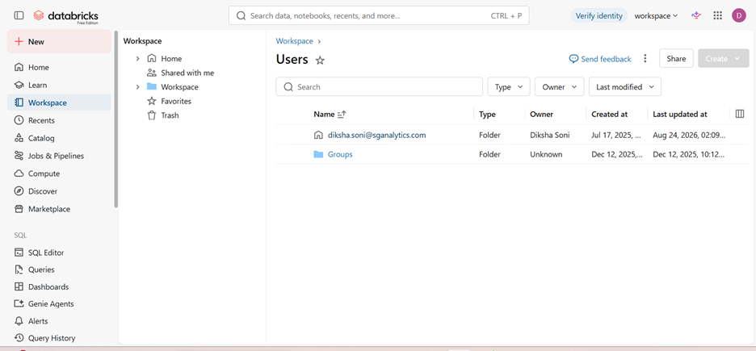
- Expand Users and right-click your username folder (or open your user folder).
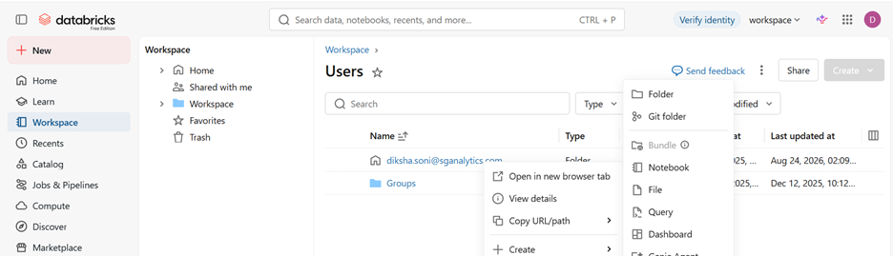
- Click Create > Git folder.
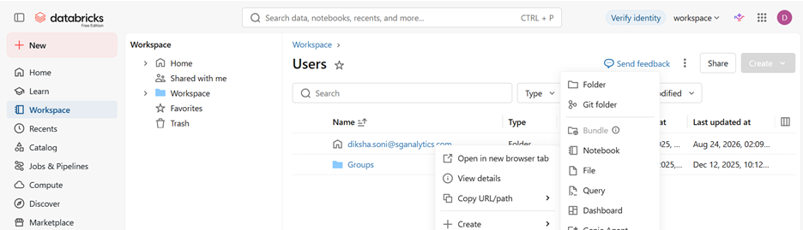
- Paste your GitHub repository URL (e.g., https://github.com/SGA-DataEngineering/databricks-training-module)
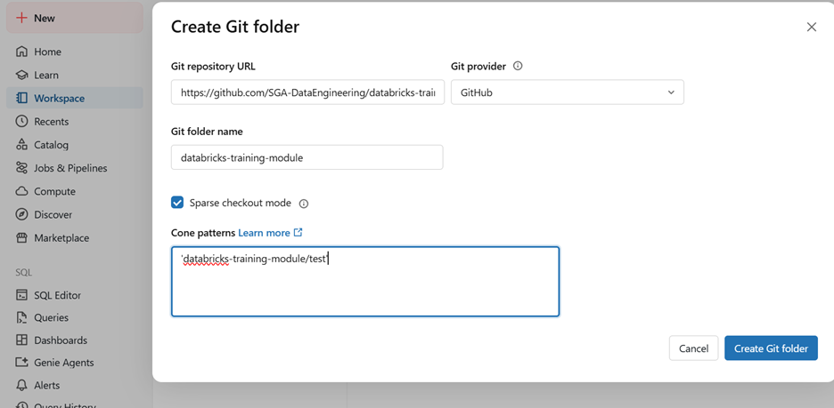
- Leave the provider as GitHub and click Create Git folder.

Step 3: Commit and Push Changes
- Open or create notebooks and code files inside your newly created Git folder.
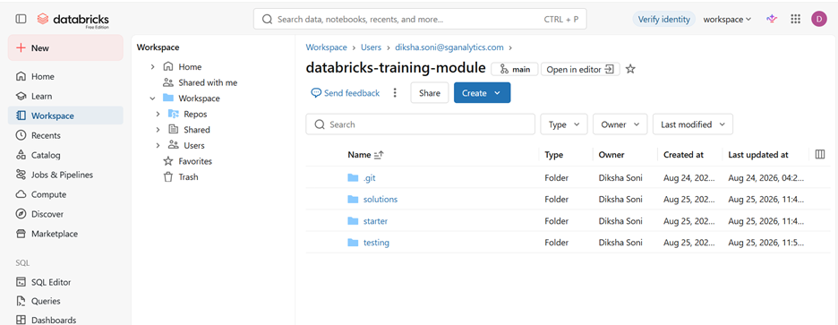
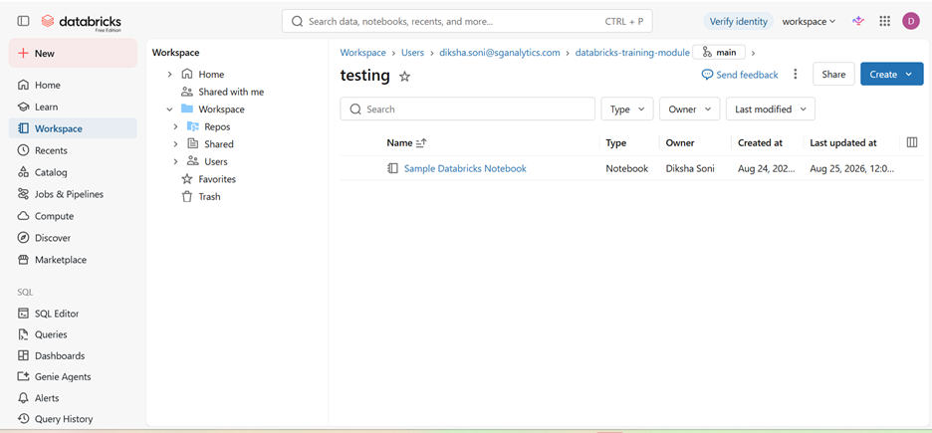
- Click the Git branch icon (next to your folder path or at the top of an open notebook).
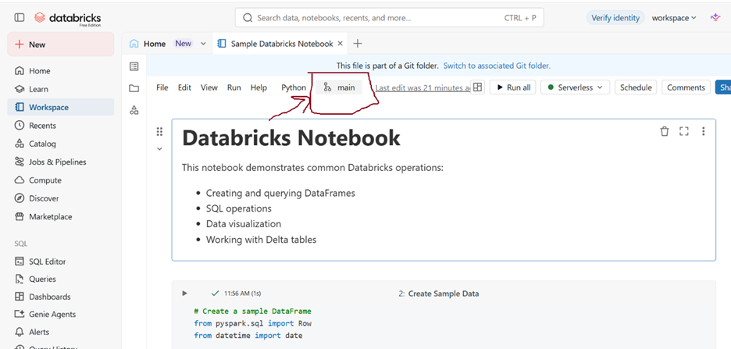

- Select your target branch or create a new branch.
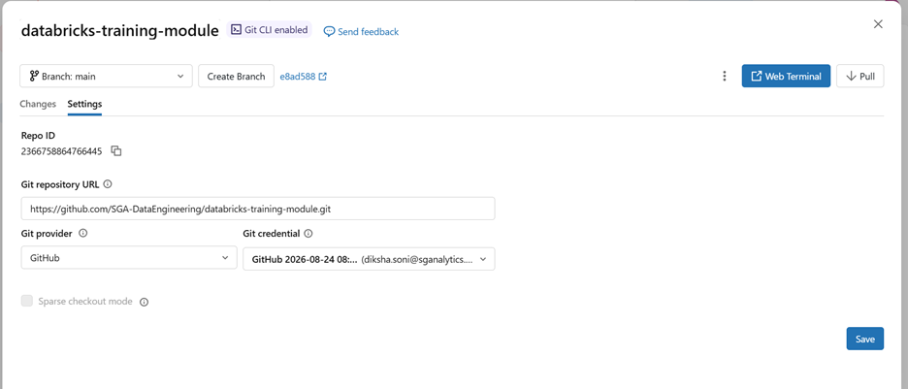

- Enter a Commit Message and click Commit & Push to push your updates directly to GitHub.

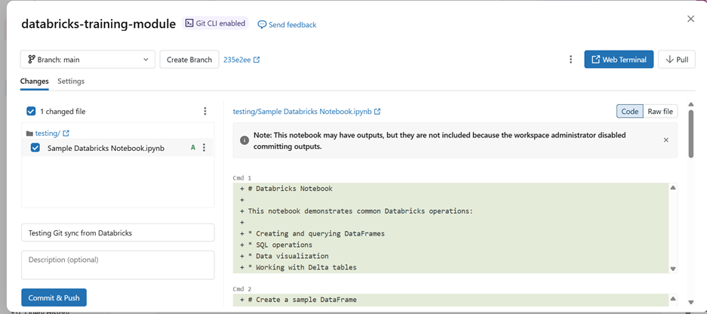

- To pull changes made on GitHub using the Web Terminal (optional)
